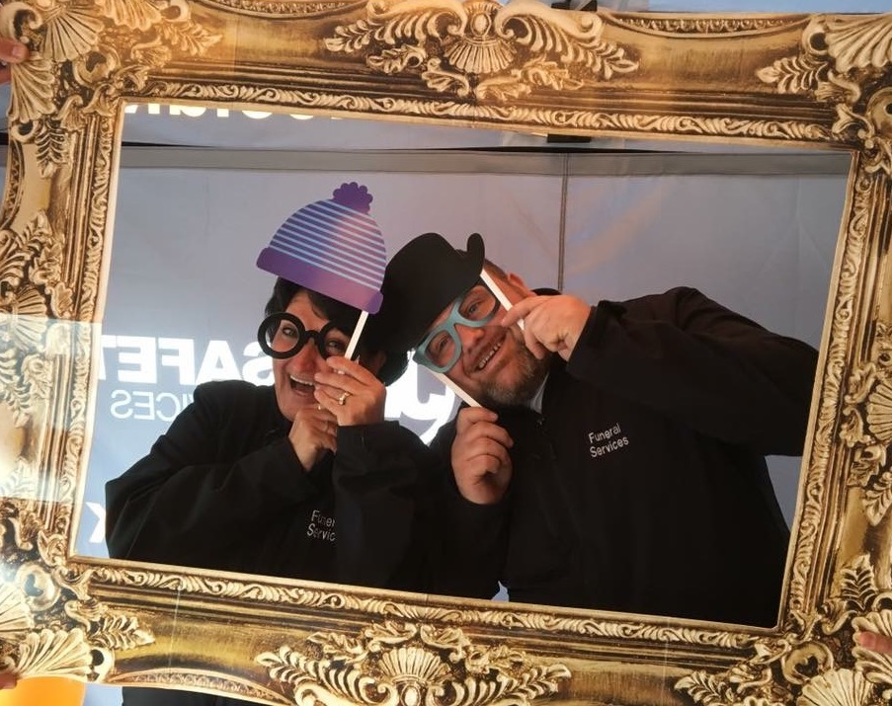

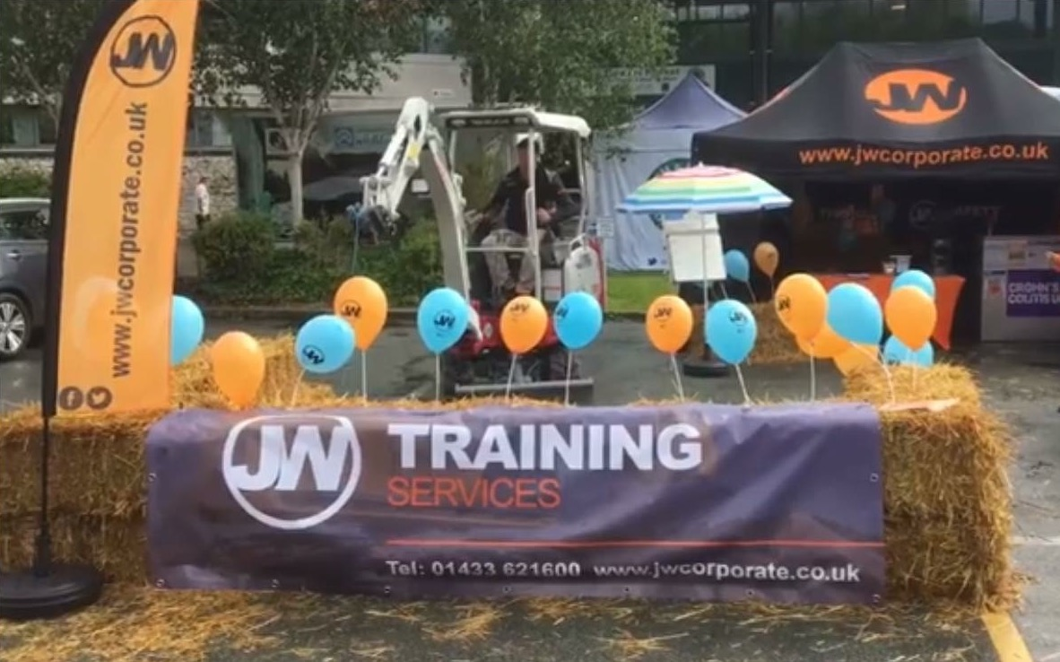

**WOW!!! Well done to each and every one of you that visited our stand at Bakewell Show this year and donated to our chosen charity Crohns & Colitis UK!**

**With your help we have managed to raise a fantastic £350.00 over the 2 day period, which is just fantastic!**

**This charity is close to our hearts and we appreciate your support very much. Well done!**

!

